**ASSIGNMENT**

* Introduction to digitle marketing

Digitle marketing is the component of marketing that utilize internet and online based digitle technologies such as desktop computers, mobile phones and other digitle midia and platforms to promot products and services.

“ Digitle marketing is a subcategory of marketing that uses digitle technology to promote and sell the products and services.”

Digitle marketing is the use of the internet,mobile devices,social media ,search engines,and otherd channels to search consumers.

Digitle marketing is the marketing and advertising of a business, person, product, or service using online channels , electronic divices, or digitle technologies.A few examplse of digitle marketing include social media, email, pay-per-lcick (PPC), search engine optimization (SEO).

Examples of digitle marketing include :

Social media marketing (SMM)

Search engine optimization (SEO)

Search engine marketing (SEM)

Email marketing .

Digitle advertising .

Content marketing .

* **Digitle world**

A world of technology is made of digitle systems.

The digitle world is the availability and use of digitle tooks . to communicate on the internet.

Digitle world use : digitle devices, smart device and other digitle technology.

Example of digitle world

1. Website
2. Blogs
3. Buying and selling online
4. Social media
5. Facebook
6. Twitter
7. Linkedin
8. Youtube
9. Pinterest
10. Netflix
11. Amazon

* Defination of Digitle Markeing

Digitle marketing is basically appling all marketing techniques to digitle channels. Different source can be used to promote servies and products like SMS , search engines , email,website ,social media and mobile device. The digitle nature of this marketing method makes it a cost-effective means of promoting one’s business

The use of digitle marketing depends on the organization’s marketing objective. It could be tha the organization wants to generate more leads, build their brands , increase sales or improve brand engagement . digitle marketing means more than just having website. The website needs to aestheticaly pleasing and easy to navigate , and also needs to have quality content to reflect the nature business.

* **Two types Of Marketing**
* **Tradition marketing and digitle marketing**

Many small business sruggle with deciding which kind of marketing to do , because their budget will only stretch to one pr the other , not both. The decision that must be made are not easy: which method of marketing will give me the most amount of sales and profits? How do I know if my marketing is working ? who should I trust with my marketing? Should I do it myself? To clarify the terms, the use of print ads on newspaper and magazines is a simple example of **traditional marketing** other examples include flyers that are put in mailboxes, comercials both on TV and redio and billboard . on the other hand , when a business invest on bulding a website, adverstising the brand name through different social media such as facebook ,twitter and youtube, this kind strategy is called digitle marketing.

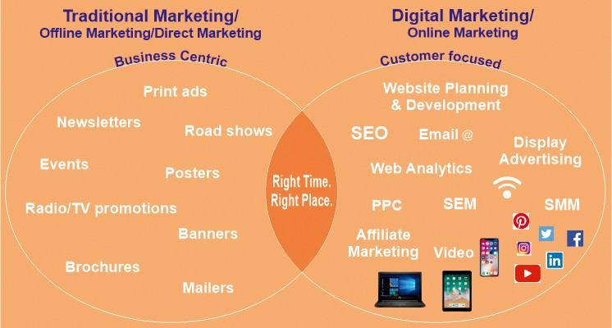

* **Digitle marketing platforms for digitle adverstising**

1. Display advertising
2. Search advertising
3. Mobile adverstising
4. Social adverstising
5. Video adverstising
6. Cross-channel adverstiding
7. Demand site plstforms